**Lab Task:**

1. Explain the output of this C program. Why the wrong value is being displayed in the output?

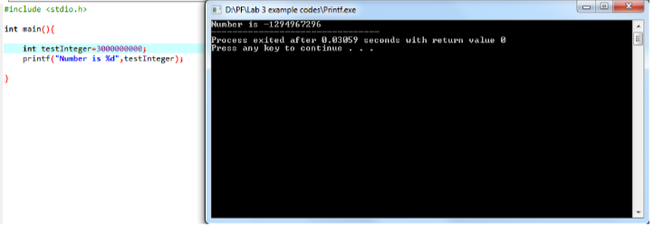

1. Write a C program that takes three integer values as input from the user. Then, swap the values such that the first value is assigned to the second variable, the second value to the third variable, and the third value to the first variable. Finally, display the output of all three variables after the rotation.
2. A driver plans a road trip to two different cities. The distance to City X from the starting point is 850 KM, and the distance from City X to City Y is 420 KM. The fuel price for the first leg of the trip (to City X) is 115/liter, and for the second leg (from City X to City Y), it is 120/liter. Write a C program to calculate the total fuel cost for the entire trip and the total fuel consumed. The program should take the car’s fuel efficiency (in kilometers per liter) as input from the user.
3. Write a C program to calculate the slope between two points (5,4) and (3,2). Ensure that the result is displayed with three decimal places.
4. A customer asks the IT firm to develop a program in C language that can take the interest rate and the principal amount from the user at runtime. The program should then calculate the interest amount the user will earn over a year and the total amount after adding the interest to the principal. This information should be provided to the user.